Reporting faults

Topic Talking about faults or problems with everyday things
Level: Entry 2 – Entry 3 / National 3-4
Time: 75 - 90 minutes

Aims
- To recognise and use vocabulary for items in a cell: light, bulb, sink, tap, telly (TV), loo (toilet).
- To talk about six faults using functional phrases: my telly / my light isn’t working, my loo won’t flush, my tap’s dripping, my sink’s blocked, the bulb’s gone.

Introduction
This lesson focuses on speaking about potential equipment faults in someone’s cell. Some activities also involve reading the phrases above but differentiation suggestions are given for those with weaker literacy skills.

You will need
Resource 1:flashcards, 1 set cut up per pair of learners
Resource 2: 1 per learner folded along the dotted line between 1a and 1b
Resource 3: 1 copy per pair of learners plus one enlarged copy or to display on screen
Resource 4: 1 copy per learner
Resource 5: 1 copy per learner

Procedure

Warmer (10 minutes)
- Put flashcards 1-6 (resource 1) face down in a pile. Explain that all the cards show a picture of something the learners would find in their cell.
- To model the activity, pick one, look at it then mime what the item is and learners have to guess.
- Nominate a confident learner to mime the item on the next flashcard.
- To add a competitive element, you could divide the in two teams and ask one person from each team to mime the item in turn.

Differentiation
- This could also be done in pairs for less confident learners.
- Instead of miming, this game could take the form of ‘Pictionary’. Learners draw the item on the board or on a piece of paper and others guess.
- Higher-level learners could try to describe the item orally without mentioning the item itself.

Activity 2 – Vocabulary input (10 minutes)
- Display 1a from resource 2 and elicit one of the words
- Hand out resource 2 (folded) and ask learners to write the appropriate word from the box underneath the picture on the handout.
- Next ask learners if they ever have any problems with any of these items and discuss their experience. This should enable you to gauge what language learners already know about the topic.
- As resource 2 is folded at this stage, if learners give any of the fault vocabulary at this stage acknowledge it, but don’t introduce any other vocabulary.

Differentiation
- For lower levels, hold the flashcards up again one at a time. Elicit and drill each of the words orally, focusing on pronunciation of new words.
- Write the six key vocabulary items randomly on the board with a number next to each one. This number should not correspond to the number on the flashcard.
- Put the learners into pairs, say one of the words and the pairs have to guess which number on the board corresponds with the spelling of that word and note down the number. Correct answers and drill then ask learners to do 1b.
- For higher levels, fold under or blank out the words given and learners write the item names from memory.

Activity 3 – Vocabulary: phrases to describe faults (20 minutes)
- Display the pictures from resource 3 on the screen or large sheet. Discuss as a class what the person’s problem could be and what they might be saying.
- Take each problem in turn and practise the problem phrase.
- Ensure that the meanings of ‘dripping, blocked, flush, gone’ are clear with board drawings or actions.
- Drill the phrases until the learners are confident.
- Show (or elicit) the contraction used in each one. Encourage learners to use the contracted form to sound more natural.
- Ask learners to unfold resource 2 to look at 1b and match the phrase with the correct picture.

Differentiation
- For emerging readers, look at each phrase in 1b and read through together and match with the picture.
- This could be used to highlight consonant and consonant cluster sounds – fl / dr / bl / sh and recognising ‘ing’.
- For starter readers, circle or underline these key words on their sheets – sink, tap, bulb, loo, light, telly. Focus on initial consonant sounds correspondence by asking them e.g. ‘Which word begins with a ‘s’ sound?’ and then get them to point to the correct picture.

Activity 3 – Guessing faults game (10 minutes)
- Use flashcards 1-6 (resource 1). Choose one of the cards but do not show the class. Tell them you have a problem in your cell and ask each learner in turn to guess the problem with the item which is shown on the card e.g. picture of a tap ‘My tap’s dripping?’
- Keep going until someone guesses. Repeat this one more time with a different card. Correct any language errors at this stage.
- Organise the learners into pairs. Learners will play the same guessing game together. Use the extra set(s) of the flashcards. Give two or three to each learner. They must not show the cards and they must guess the faults in each other’s cell.

Differentiation
Stronger learners could ask questions e.g. ‘Is your tap dripping?’

Activity 4 – Storyboard role play (15 minutes)
    - Group learners according to level and display Resource 3 again. Point to the first problem and elicit what he might be saying (‘My telly’s broken’) and ask ‘How do you think he feels?’
    - Point to 3 and elicit this problem (‘My tap’s dripping’). Ask ‘How do you think he feels?’ and demonstrate how annoying a dripping tap can be. Elicit ‘It drives me crazy’).
    - Point to 4 and elicit what his problem is (‘My sink’s blocked’). Ask ‘If something is broken, what do you need to do?’ to elicit the word ‘fix’.
    - Display Resource 4 and give a copy to a stronger learner. Taking the different parts, read through the dialogue slowly with the class following. Establish meanings of words and phrases such as ‘bored/ fix/ drive (me) crazy’
    - Learners can then read the role play together in pairs, swapping roles.
    - Hand out Resource 3, one between two. Learners will do a paired role play based on the picture storyboard but encourage them to add their own extra phrases. Model this with a stronger learner first.
    - If appropriate, listen to pairs doing their role play as a whole class.

Differentiation
- For lower-level readers, while the other learners are practising the dialogue from resource 4, use resource 3 to elicit and practise a simplified version of the dialogue.
- Start with ‘What’s the matter?’ then pointing to picture 1, ask a learner to say ‘My telly’s broken.’
- Then point at picture 2 and say ‘What about you? Do this until you’ve covered all the issues in the pictures.
- Next divide the group into 2, one half acts as Kemal and the other half as Errol. Get them to ask questions and give the answers for all the pictures. Prompt if necessary.
- Finally learners practise in pairs.
- After this, give the learners the copy with words and ask them to pick out, underline and say the key phrases.
- Starter readers can try to pick out and underline the key words.

Cooler (10 minutes)
- Hold one of flashcards 1-6 up, elicit the problem and ask learners if they currently have any such problems in their cell. Let learners respond and discuss the situation.
- Encourage them to expand on their answers. Work through all the cards and any other scenarios they bring up.

Extension activity/ Homework – resource 5: more phrases for domestic problems
- Learners need to add one of the verbs phrases previously used to the noun given to make an appropriate sentence to describe a new fault or problem.
- They could role play the situations related to the pictures with a different partner.
- Learners could write a short letter of complaint about one of the problems. This could be similar to the type of activities on exam papers. See the Inside Time lesson plan for more information about writing letters of complaint.
- Also Unit 2 of Legal matters: making complaints.

Answers

Resource 2 Task1b: 1d 2c 3e 4b 5a 6f

Resource 5: Extension activity:
1. My pen isn’t working.
2. My toilet’s blocked.
3. The pipe’s dripping.
4. The hoover isn’t working.
5. The washing machine isn’t working.
6. The shower’s dripping.

1 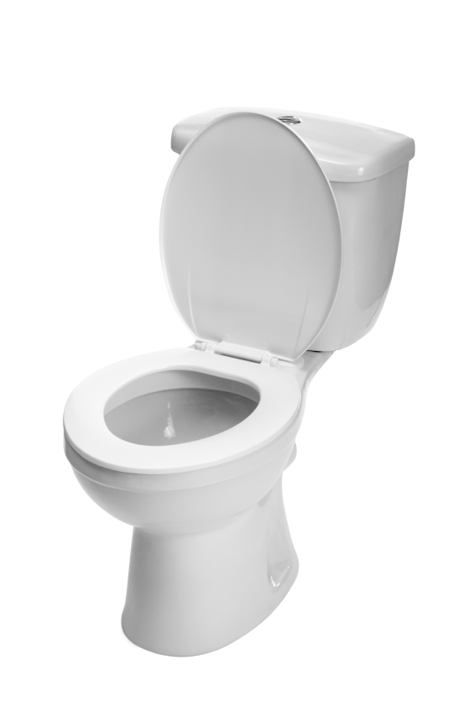 | 2
3 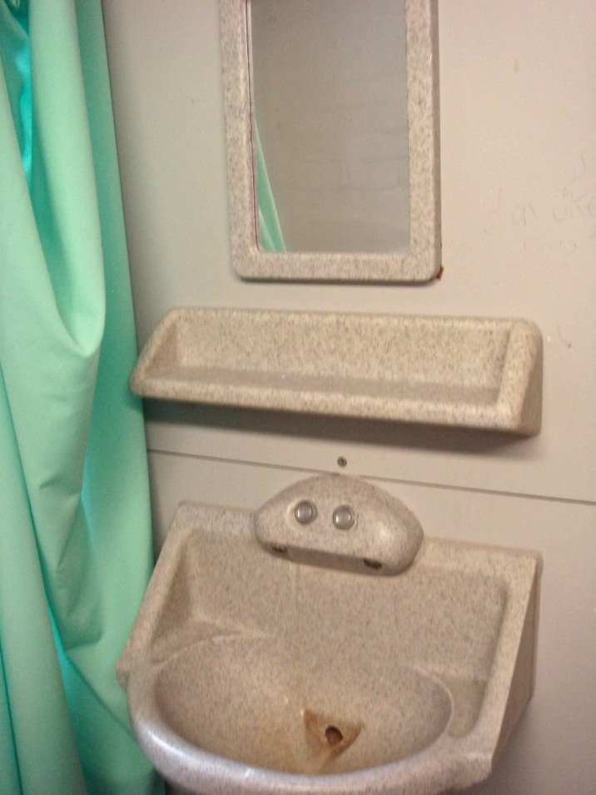 | 4 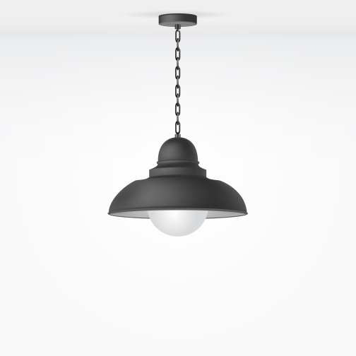
5 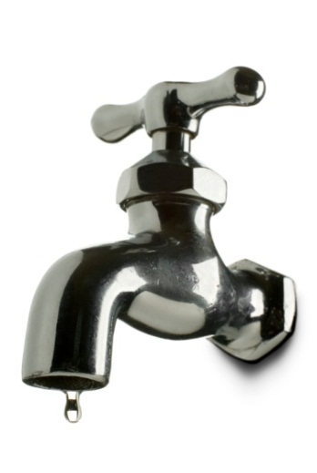 | 6 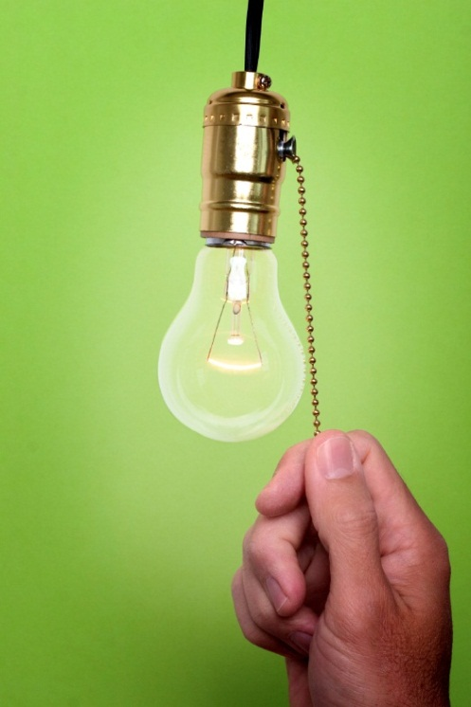
Resource 1

Resource 2

1a. Write the correct word underneath the picture.
 |  | 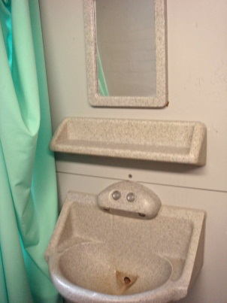
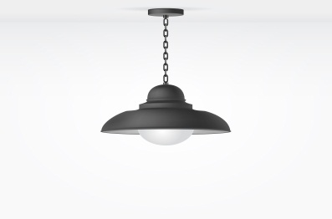 | 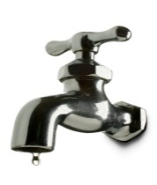 | 
tap toilet sink bulb TV light loo telly

- - - - - - - - - - - - - - - - - - - - - - - - - - - - - - - - - - - - - - - - - - - - - - - - - - - - - - - - - - - - - -

1b. Match the problem and the picture.
1. 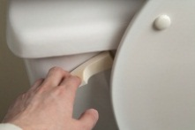 | a. My sink’s blocked.
2. 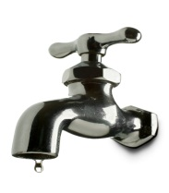 | b. The bulb’ s gone
3.  | c. My tap’s dripping.
4. 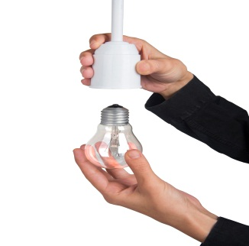 | d. My loo won’t flush.
5. 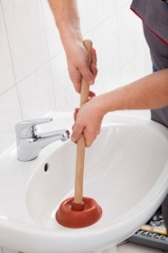 | e. My telly isn’t working.
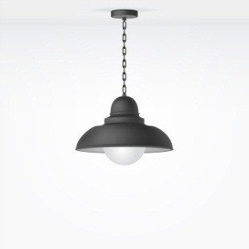  6.. | f. My light isn’t working.

Resource 3

1. Kemal  |  |  | 2. Ali  . | 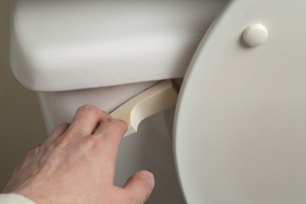 |  | 3. Kemal   | 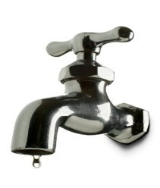
4. Errol   |  | 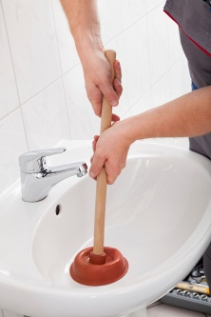 | 5. Kemal   |  | 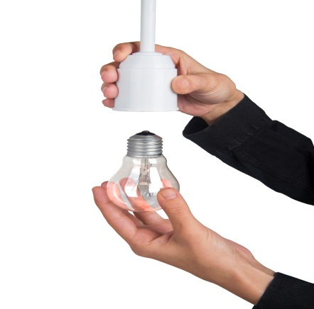 | 6. Ali   | 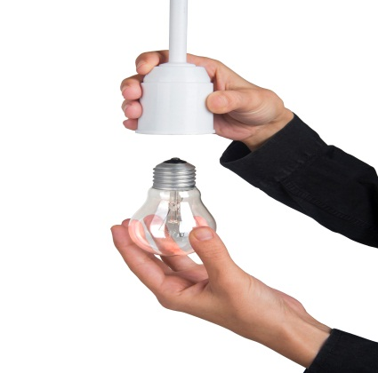

Resource 4

I hope they fix that for you soon! My tap’s dripping. It drives me crazy.
I’m really bored. My telly isn’t working.
Really? In my cell my loo won’t flush.

1. Kemal  |  | 2. Ali  . | 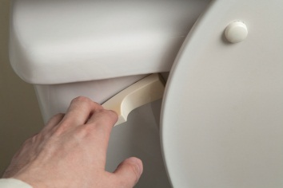 | 3. Kemal   | 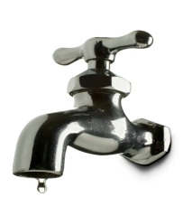
4. Errol    I bet. My sink’s blocked but they will fix it tomorrow. | 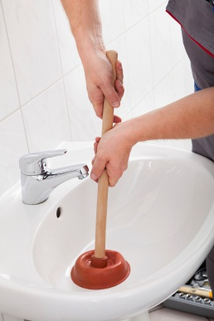 | 5. Kemal  That’s good. The bulb’s gone too. I can’t see anything.   | 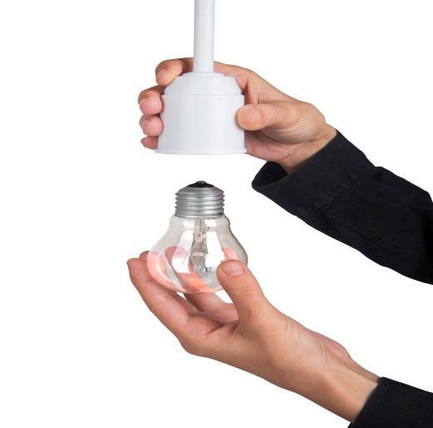 | 6. Ali    Me too. My light isn’t working. The bulb is OK. I don’t know what the problem is. | 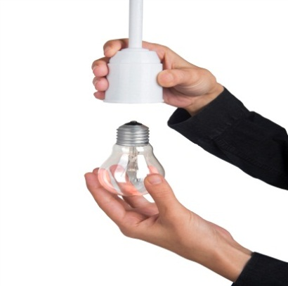

Resource 5

1   My pen …………………………………. | 2   My toilet …………………………………
3 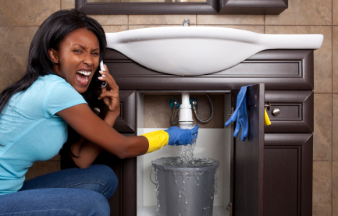  The pipe ……………………………….. | 4 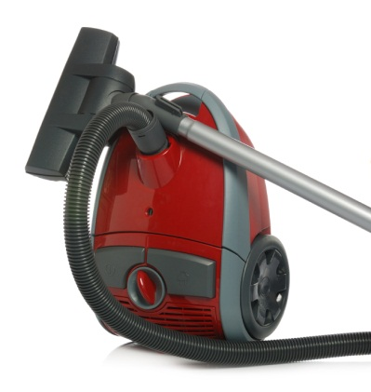  The hoover …………………………….
5 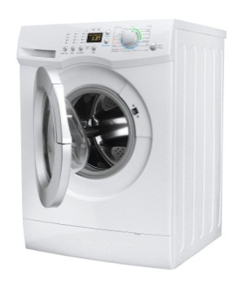  The washing machine………………….  …………………………………………… | 6 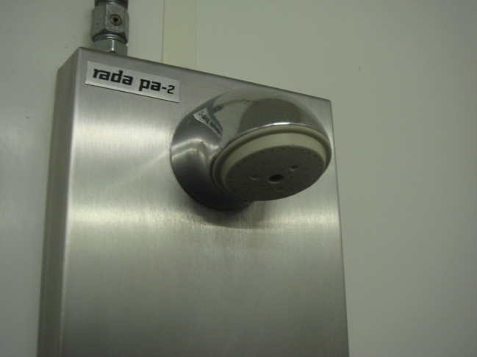  The shower …………………………….

